Glossary

Version 4.2
Revision History
Date | Version | Description | Author
June, 1999 | V4.2 | Initial creation | Shawn Siemers

Table of Contents
1. Introduction 5
2. Definitions 5
2.1 Abstract Class 5
2.2 Abstraction 5
Action 5
2.4 Active Class 5
2.5 Activity Diagram 5
2.6 Activity 5
2.7 Actor 6
Aggregation 6
2.9 Analysis 6
2.10 Analysis Class 6
2.11 Analysis Mechanism 6
2.12 Architectural Mechanism 6
2.13 Architecture 6
2.14 Association Class 7
2.15 Association 7
2.16 Attribute 7
2.17 Boundary Class 7
2.18 Class 7
2.19 Collaboration Diagram 7
2.20 Component 8
2.21 Composition 8
2.22 Control Class 8
2.23 Dependency 8
2.24 Deployment Diagram 8
2.25 Deployment View 8
2.26 Derived Attribute 8
2.27 Design 8
2.28 Design Model 8
2.29 Design Mechanism 9
2.30 Encapsulation 9
2.31 Entity Class 9
2.32 Event 9
2.33 Façade Class 9
2.34 Framework 9
2.35 Generalization 9
2.36 Implementation Mechanism 10
2.37 Implementation View 10
2.38 Inheritance 10
2.39 Interface 10
2.40 Logical View 10
2.41 Message 10
2.42 Method 10
2.43 Modularity 11
2.44 Multiplicity 11
2.45 Navigability 11
2.46 Node 11
2.47 Object 11
2.48 Operation 11
2.49 Package 11
2.50 Pattern 11
2.51 Polymorphism 11
2.52 Process 12
2.53 Process View 12
2.54 Property 12
2.55 Realization 12
2.56 Responsibility 12
2.57 Role 12
2.58 Scenario 12
2.59 Sequence Diagram 12
2.60 State 12
2.61 Statechart 13
2.62 Stereotype 13
2.63 Subsystem 13
2.64 Thread 13
2.65 Transition 13
2.66 Use Case 13
2.67 Use Case Model 13
2.68 Use Case Realization 13
2.69 Use Case View 13
2.70 Utility Class 13
2.71 Visibility 13

Glossary

Introduction
This document contains definitions for the terms used within the Object Oriented Analysis and Design Using the UML (OOAD/UML) course. The majority of the definitions were taken from the Rational Unified Process. Some were taken directly from the OOAD/UML course materials, or paraphrased from the UML User’s Guide, or a combination of both. Graphics were included where they helped to explain the definition.

Definitions

Abstract Class
A class that cannot be directly instantiated; the opposite of a concrete class.

Abstraction
The essential characteristics of an entity that distinguish it from all other kind of entities and thus provide crisply-defined boundaries relative to the perspective of the viewer.

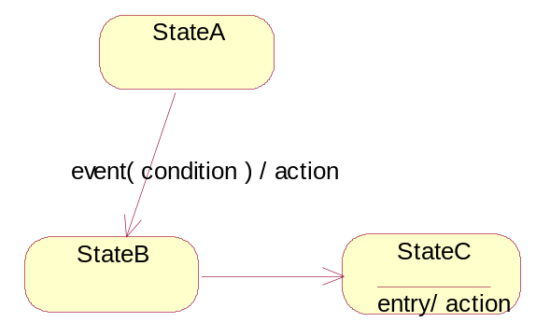
Action
An action is an operation that is associated with a transition. Actions conceptually take an insignificant amount of time to complete, and are considered non-interruptible. Action names are shown on the transition arrow preceded by a slash.

Active Class
An active class is a class that “owns” it’s own thread of execution and can initiate control activity, contrasted with passive classes that can only be acted upon. Active classes my execute in parallel (i.e., concurrently) with other active classes.

Activity Diagram
A diagram that models the flow from activity to activity. It is used to model the dynamic view of a system.

Activity
A unit of work a worker may be asked to perform

Actor
Someone or something, outside the system or business that interacts with the system or business.

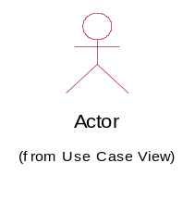
Aggregation
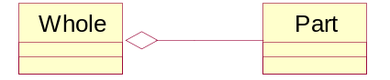
An association that models a whole-part relationship between an aggregate (the whole) and its parts.

Analysis
The part of the software development process whose primary purpose is to formulate a model of the problem domain. Analysis focuses on what to do, design focuses on how to do it.

Analysis Class
Analysis classes handle primarily functional requirements, and model objects from the "problem" domain.

Analysis Mechanism
An architectural mechanism used early in the design process, during the period of discovery when key classes and subsystems are being identified. Typically analysis mechanisms capture the key aspects of a solution in a way that is implementation independent. Analysis mechanisms are usually unrelated to the problem domain, but instead are "computer science" concepts. They provide specific behaviors to a domain-related class or component, or correspond to the implementation of cooperation between classes and/or components. They may be implemented as a framework. Examples include mechanisms to handle persistence, inter-process communication, error or fault handling, notification, and messaging, to name a few.

Architectural Mechanism
An architectural mechanism represents a common solution to a frequently encountered problem. They may be patterns of structure, patterns of behavior, or both.

Architecture
The highest level concept of a system in its environment [IEEE]. The architecture of a software system (at a given point in time) is its organization or structure of significant components interacting through interfaces, those components being composed of successively smaller components and interfaces.

Association Class
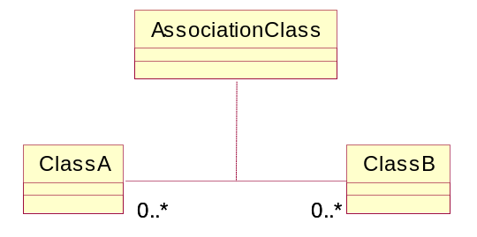
An association class is a class that is connected to an association. It is a full-fledged class and can contain attributes, operations and other associations. Association classes allow you to store information about the relationship itself. Such information is not appropriate, or does not belong, within the classes at either end of the relationship.

Association
A relationship that models a bi-directional semantic connection among instances.

Attribute
An attribute defined by a class represents a named property of the class or its objects. An attribute has a type that defines the type of its instances.

Boundary Class
A class used to model communication between the system's environments and its inner workings.

Class
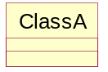
A class is a description of a set of objects that share the same responsibilities, relationships, operations, attributes, and semantics.

Collaboration Diagram
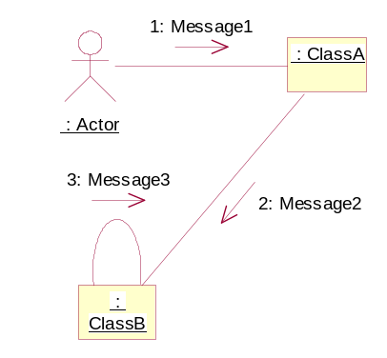
A collaboration diagram describes a pattern of interaction among objects; it shows the objects participating in the interaction by their links to each other and the messages they send to each other.

Component
A non-trivial, nearly independent, and replaceable part of a system that fulfills a clear function in the context of a well-defined architecture. A component conforms to and provides the physical realization of a set of interfaces.

Composition
A form of aggregation with strong ownership and coincident lifetime of the parts by the whole.
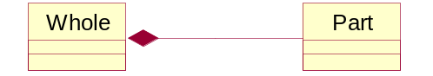

Control Class
A class used to model behavior specific to one, or a several use cases.

Dependency
A semantic relationship between two things in which a change to one thing (the independent thing) may affect the semantics of the other thing (dependent thing).

Deployment Diagram
A diagram that shows the configuration of run time processing nodes and the components that live on them. A deployment diagram addresses the static view of the system.
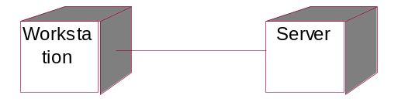

Deployment View
An architectural view that describes one or several system configurations; the mapping of software components (tasks, modules) to the computing nodes in these configurations.

Derived Attribute
An attribute whose value may be calculated based on the value of other attribute(s).

Design
The part of the software development process whose primary purpose is to decide how the system will be implemented. During design, strategic and tactical decisions are made to meet the required functional and quality requirements of a system.

Design Model
An object model describing the realization of use cases; serves as an abstraction of the implementation model and its source code.

Design Mechanism
An architectural mechanism used during the design process, during the period in which the details of the design are being worked-out. They are related to associated analysis mechanisms, of which they are additional refinements. A design mechanism assumes some details of the implementation environment, but it is not tied to a specific implementation (as is an implementation mechanism). For example, the analysis mechanism for inter-process communication may be refined by several design mechanisms for interprocess communication (IPC): shared memory, function-call-like IPC, semaphore-based IPC, and so on. Each design mechanism has certain strengths and weaknesses; the choice of a particular design mechanism is determined by the characteristics of the objects using the mechanism.

Encapsulation
The physical localization of features (e.g., properties, behaviors) into a single black box abstraction that hides their implementation (and associated design decisions) behind a public interface. Encapsulation is also referred to as information hiding.

Entity Class
A class used to model information that has been stored by the system, and the associated behavior. A generic class reused in many use cases, often with persistent characteristics. An entity class defines a set of entity objects, which participate in several use cases and typically survive those use cases.

Event
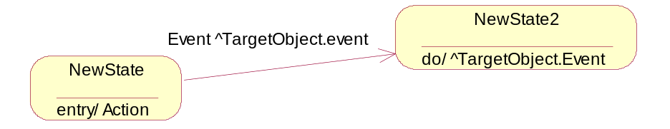
An event is an occurrence that happens at some point in time. In a statechart, an event is an occurrence of a stimulus that can trigger a state transition.

Façade Class
A class that acts as the entry point to a subsystem.

Framework
A micro-architecture that provides an incomplete template for applications within a specific domain

Generalization
A taxonomic relationship between a more general element and a more specific element. The more specific element is fully consistent with the more general element and contains additional information. An instance of the more specific element can be used where the more general element is allowed.
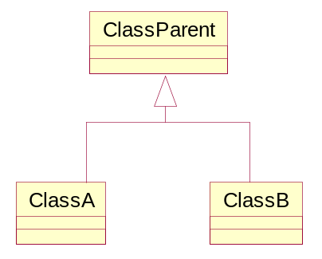

Implementation Mechanism
An architectural mechanism used during the implementation process. They are refinements of design mechanisms, and specify the exact implementation of the mechanism. For example, one particular implementation of the inter-process communication analysis mechanism is a shared memory design mechanism utilizing a particular operating system’s shared memory function calls. Concurrency conflicts (inappropriate simultaneous access to shared memory) may be prevented using semaphores, or using a latching mechanism, which in turn rest upon other implementation mechanisms.

Implementation View
An architectural view that describes the organization of the static software elements (code, data, and other accompanying artifacts) on the development environment, in terms of both packaging, layering, and configuration management (ownership, release strategy, and so on). In the Unified Process it is a view on the implementation model.

Inheritance
The mechanism that makes generalization possible; a mechanism for creating full class descriptions out of individual class segments.

Interface
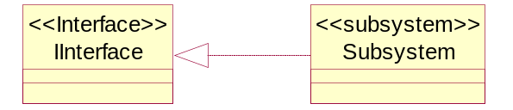
A collection of operations that are used to specify a service of a class or a component.

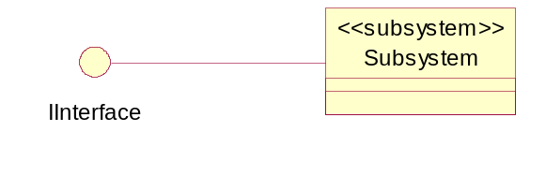

Logical View
An architectural view that describes the main classes in the design of the system: major business-related classes, and the classes that define key behavioral and structural mechanisms (persistency, communications, fault-tolerance, user-interface). In the Unified Process, the logical view is a view of the design model.

Message
A specification of a communication between objects that conveys information with the expectation that activity will ensue.

Method
(1)A regular and systematic way of accomplishing something; the detailed, logically ordered plans or procedures followed to accomplish a task or attain a goal. (2) UML 1.1: The implementation of an operation, the algorithm or procedure that effects the results of an operation.

Modularity
The logical and physical decomposition of things (e.g., responsibilities and software) into small, simple groupings (e.g., requirements and classes, respectively), which increase the achievements of software-engineering goals.

Multiplicity
A specification of the range of allowable cardinalities that a set may assume.
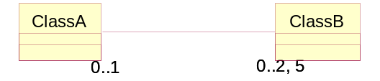

Navigability
The navigability property on a role indicates that it is possible to navigate from a associating class to the target class using the association.

Node
A run-time physical object that represents a computational resource, generally having at least a memory and often processing capability as well. Run-time objects and components may reside on nodes.
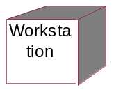

Object
An entity with a well-defined boundary and identity that encapsulates state and behavior. State is represented by attributes and relationships, behavior is represented by operations and methods. An object is an instance of a class.

Operation
A service that can be requested from an object to effect behavior.

Package
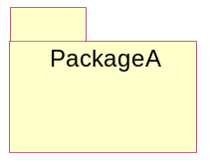
A grouping of modeling elements.

Pattern
A scheme for describing design fragments or collections of class templates so that they can be configured and reused.

Polymorphism
Polymorphism is the ability to define a single interface with multiple implementations.

Process
(1) Any thread of control that can logically execute concurrently with other processes. (2) A set of partially ordered steps intended to reach a goal; in software engineering the goal is to build a software product or to enhance an existing one; in process engineering, the goal is to develop or enhance a process model; corresponds to a business use case in business engineering.

Process View
An architectural view that describes the concurrent aspect of the system: tasks (processes) and their interactions.

Property
A named value denoting a characteristic of an element.

Realization
A semantic relationship between classifiers, in which one classifier specifies a contract that another classifier guarantees to carry out.

Responsibility
A contract or obligation of a type or class.

Role
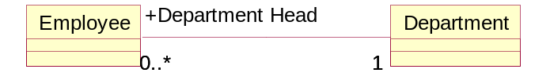
The behavior of an entity participating in a particular context.

Scenario
A described use-case instance, a subset of a use case.

Sequence Diagram
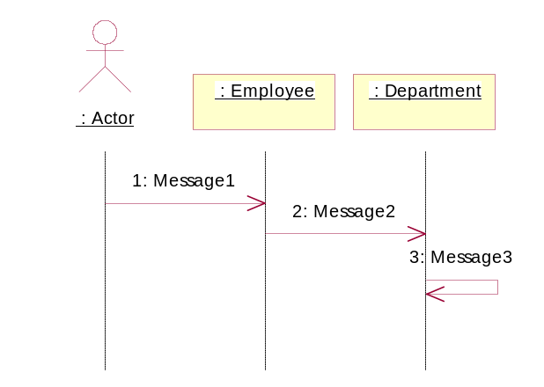
A diagram that describes a pattern of interaction among objects, arranged in a chronological order; it shows the objects participating in the interaction by their "lifelines" and the messages that they send to each other.

State
A condition or situation during the life of an object during which it satisfies some condition, performs some activity, or waits for some event.

Statechart
A state diagram shows a state machine, that is, a behavior that specifies the sequences of states that an object goes through during its life in response to events, together with its responses and actions.
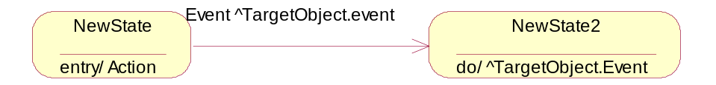

Stereotype
A meta-classification of an element. Stereotypes have semantic implications which can be specified for every specific stereotype value.

Subsystem
A model element which has the semantics of a package, such that it can contain other model elements, and a class, such that it has behavior. (The behavior of the subsystem is provided by classes or other subsystems it contains). A subsystem realizes one or more interfaces, which define the behavior it can perform.

Thread
An independent computation executing within an the execution environment and address space defined by an enclosing operating system process.

Transition
A transition is a change from an originating state to a successor state as a result of some stimulus.

Use Case
A use case defines a set of use-case instances, where each instance is a sequence of actions a system performs that yields an observable result of value to a particular actor. A use-case class contains all main, alternate flows of events related to producing the 'observable result of value'. Technically, a use-case is a class whose instances are scenarios.

Use Case Model
A model of what the system is supposed to do and the system environment.

Use Case Realization
A use-case realization describes how a particular use case is realized within the design model, in terms of collaborating objects.

Use Case View
An architectural view that describes how critical use cases are performed in the system, focusing mostly on architecturally significant components (objects, tasks, nodes). In the Unified Process, it is a view of the use-case model.

Utility Class
A class that contains a collection of free subprograms.

Visibility
How a name can be seen and used by others.

G. Booch, et al., The Unified Modeling Language User Guide, Addison Wesley Longman, Inc., 1998; ISBN 0-201-571684

